**04/10/2021 CD LAB 5 2019103573**

**LEX PROGRAM**

**READING FROM FILE**

**1. Reading input from a file**

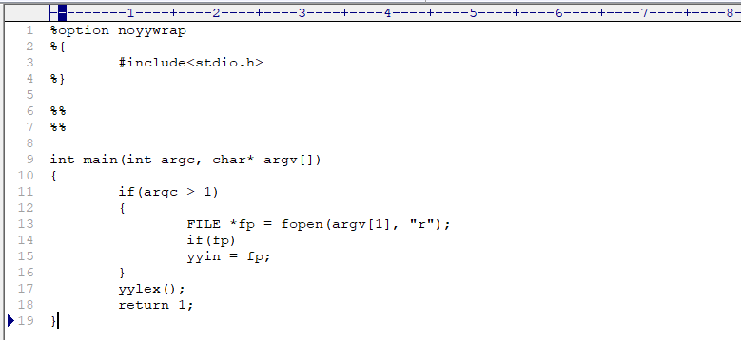**CODE :-**

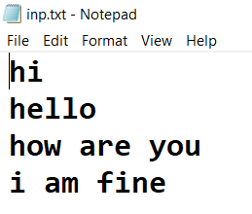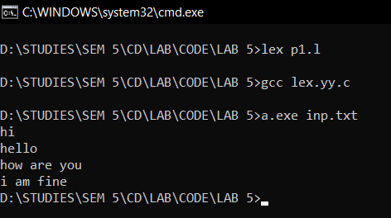**OUTPUT :-**

**READING AND WRITING INTO FILE**

**2. Replace the character with another character using file**

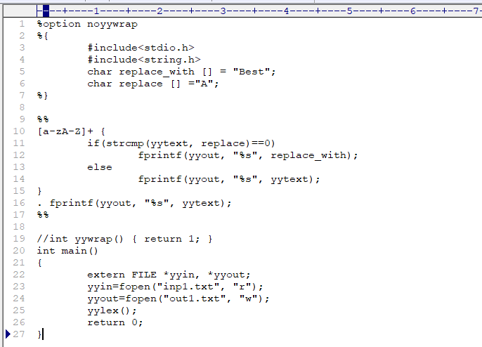**CODE :-**

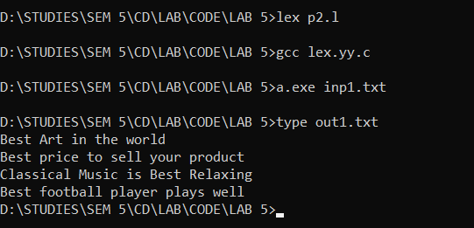**OUTPUT :-**

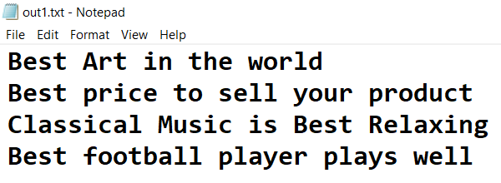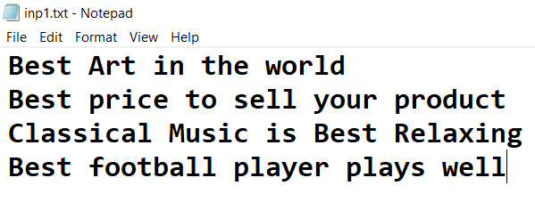

**3. yyless(k) - returns the first k characters in yytext**

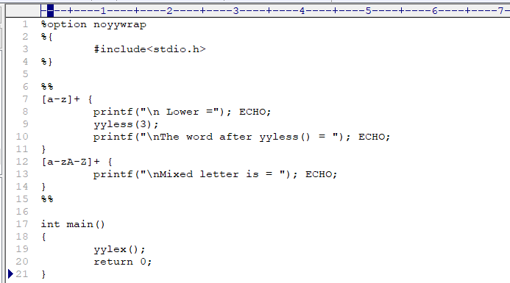**CODE :-**

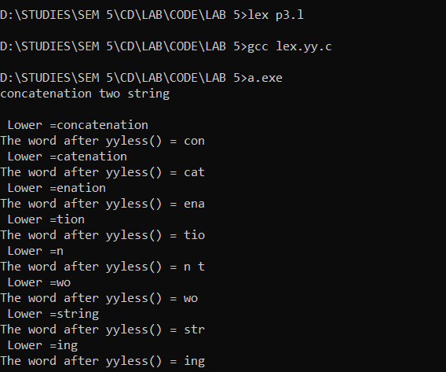**OUTPUT :-**

**4. ymore() - returns the next token.**

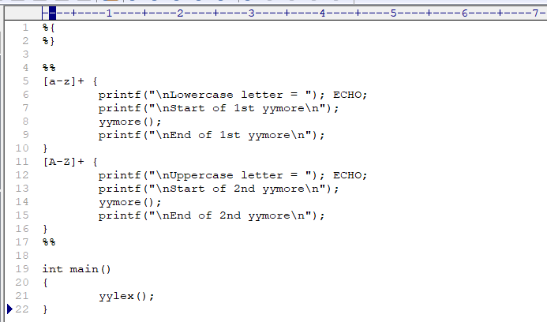**CODE :-**

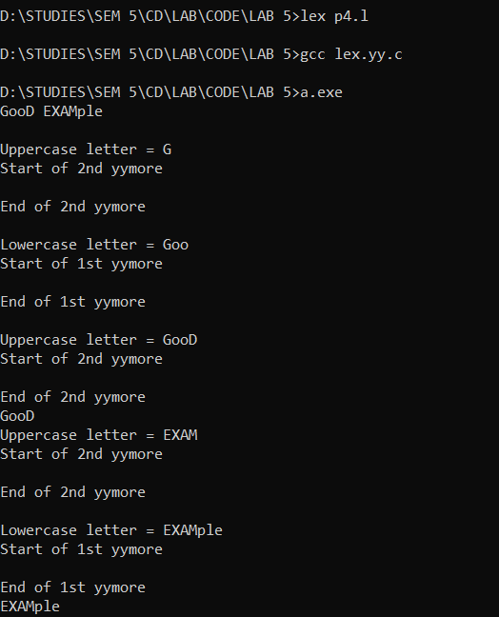**OUTPUT :-**